1. : Go to Gmail/ Facebook (any) website and give valid username & password and login (Using ID)

# Code Class1.class

|  |
| --- |
| package pract3;  import org.openqa.selenium.By; import org.openqa.selenium.WebDriver; import org.openqa.selenium.WebElement; import org.openqa.selenium.chrome.ChromeDriver; import java.util.*;    public class class1 {    public static void main(String[] args) {  WebDriver driver = null;  driver = new ChromeDriver();  driver .get("https://adactinhotelapp.com/");  // using id  WebElement we3=driver.findElement(By.*id*("username"));  we3.sendKeys("Supereme_Tester123"); // printing the username is cmd  String str = we3.getAttribute("value");  System.*out*.println(str);    }  } |

OUTPUT:

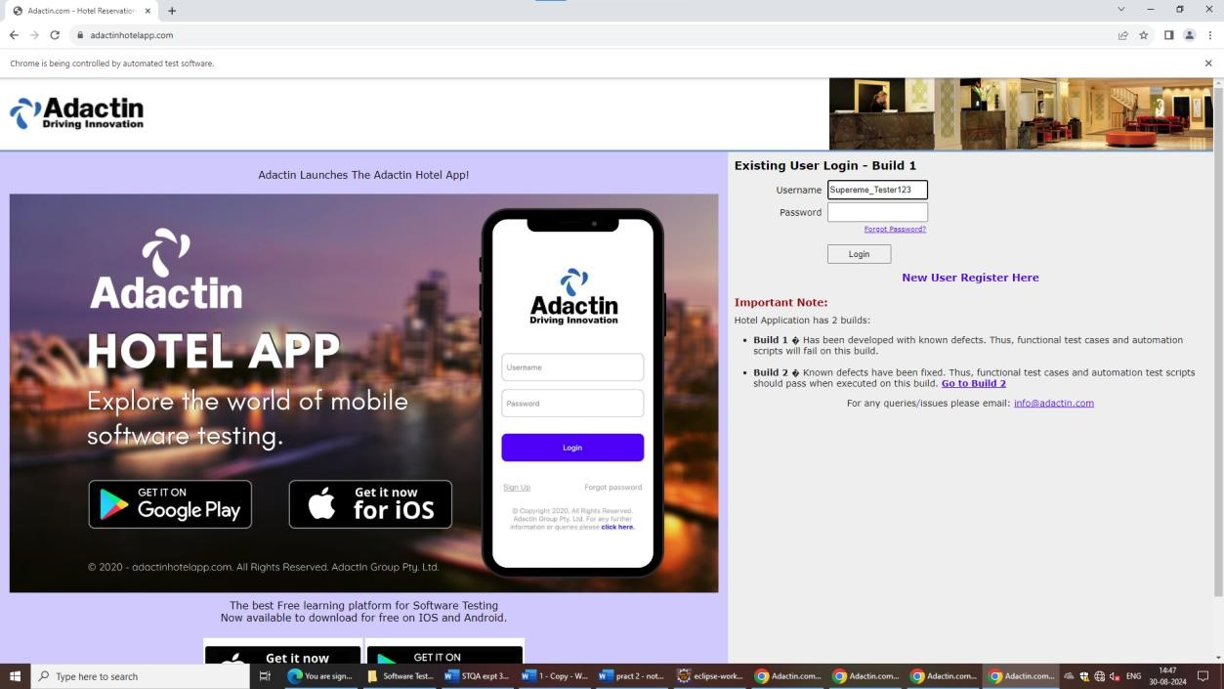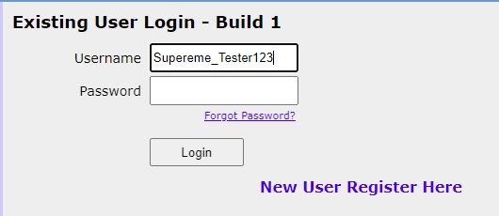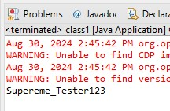

1. AIM: Go to any website and give Invalid username &password and try to login (Using name, class name , tagname)

CODE:

|  |
| --- |
| package pract3; import org.openqa.selenium.By; import org.openqa.selenium.WebDriver; import org.openqa.selenium.WebElement; import org.openqa.selenium.chrome.ChromeDriver; import java.util.*;    public class class1 {    public static void main(String[] args) {  WebDriver driver = null; driver = new ChromeDriver(); driver .get("https://adactinhotelapp.com/");  // using id  WebElement we1=driver.findElement(By.name("username")); we1.sendKeys("Supereme_Tester");  //in cssSelector - tagname and id is used driver.findElement(By.cssSelector("input#password")).sendKeys("aatrocks");  // input button  WebElement we3 = driver.findElement(By.className("login_button")); we3.click();    }  } |

OUTPUT:

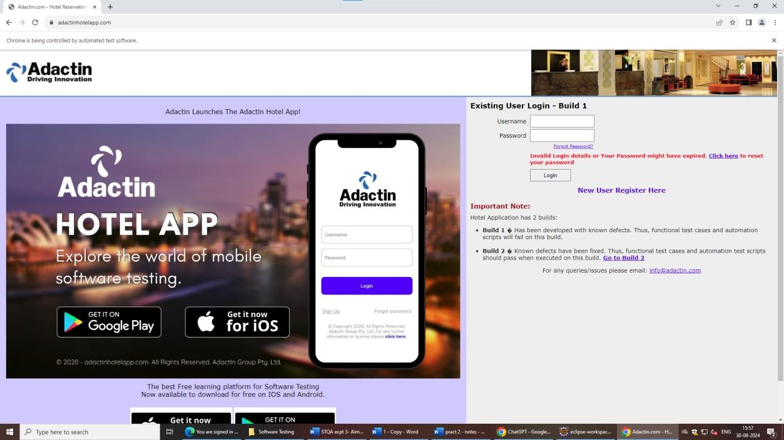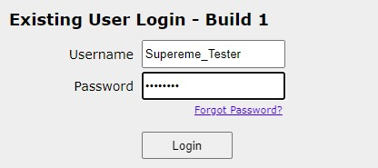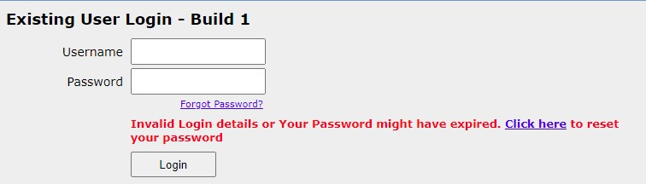

1. AIM: Go to any website, give user name & password and print that user name and password (using any locator)

CODE:

|  |
| --- |
| package pract3; import org.openqa.selenium.By; import org.openqa.selenium.WebDriver; import org.openqa.selenium.WebElement; import org.openqa.selenium.chrome.ChromeDriver; import java.util.*;    public class class1 {    public static void main(String[] args) {  WebDriver driver = null;    driver = new ChromeDriver(); driver .get("https://adactinhotelapp.com/");  // here selector is copied from webpage  WebElement we3=driver.findElement(By.cssSelector("#username")); we3.sendKeys("aatrocks");  String str = we3.getAttribute("value");  System.out.println(str);    }  } |

OUTPUT:

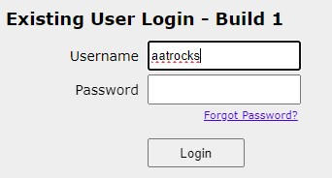

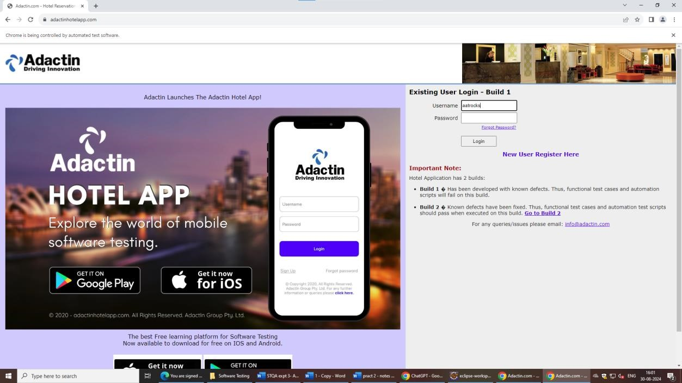

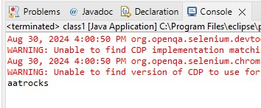

1. AIM: Fill the details of new account creation form of any application (Gmail/Facebook) CODE:

|  |
| --- |
| package pract3; import org.openqa.selenium.By; import org.openqa.selenium.WebDriver; import org.openqa.selenium.WebElement; import org.openqa.selenium.chrome.ChromeDriver; import java.util.*;    public class class1 {    public static void main(String[] args) {  WebDriver driver = null; driver = new ChromeDriver(); driver .get("https://www.saucedemo.com/v1/");  // using username  WebElement we1=driver.findElement(By.id("user-name")); we1.sendKeys("problem_user");  //using password  driver.findElement(By.id("password")).sendKeys("secret_sauce");  // input button  WebElement we3 = driver.findElement(By.id("login-button")); we3.click();    }  } |

OUTPUT

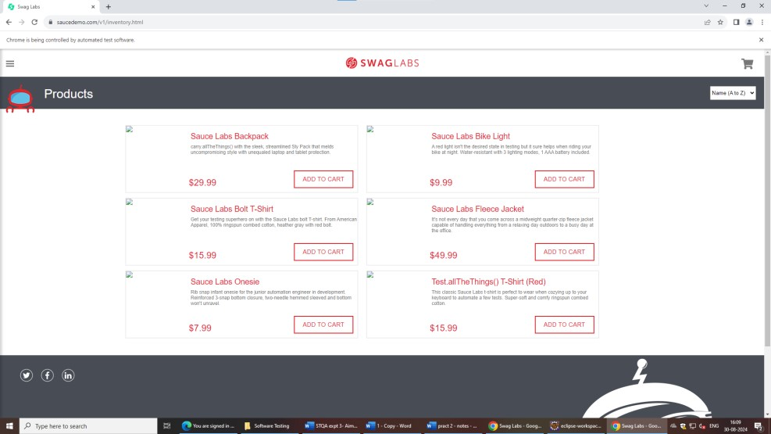

1. Go to google.com, check the google logo is available or not (using CSS selector) CODE:

|  |
| --- |
| package pract3;    import org.openqa.selenium.By; import org.openqa.selenium.WebDriver; import org.openqa.selenium.WebElement;  import org.openqa.selenium.chrome.ChromeDriver;    public class class1 {    public static void main(String[] args) {    WebDriver driver = null;  driver = new ChromeDriver();  driver.get("https://www.google.com/");    try {  //selected from copy  WebElement logo = driver.findElement(By.*cssSelector*("#hplogo"));    if (logo != null) {  System.*out*.println("Logo is present."); } else {  System.*out*.println("Logo is not found.");  }  } catch (Exception e) {  System.*out*.println("Logo is not found.");  } finally {  // Close the browser driver.quit();  }  }  } |

OUTPUT

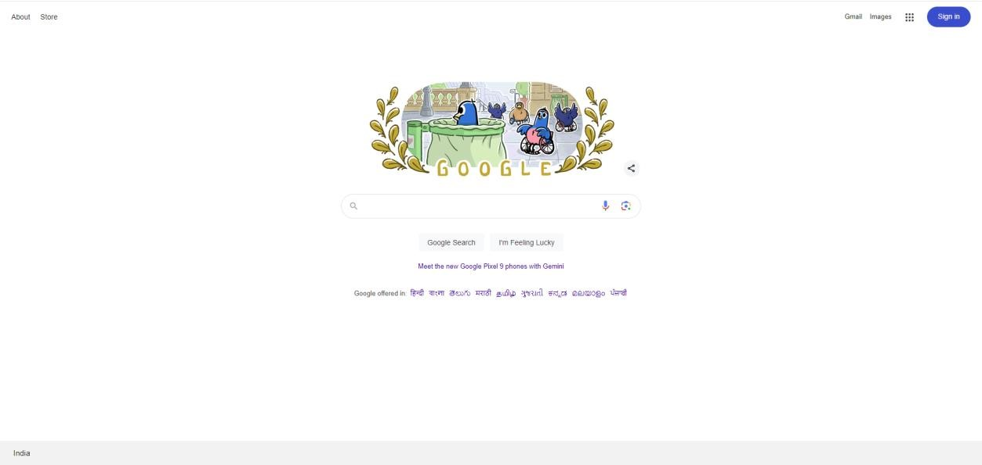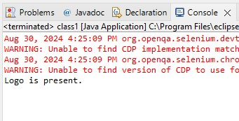

1. Gmail account login(using Xpath)

|  |
| --- |
| package pract3;    import org.openqa.selenium.By; import org.openqa.selenium.WebDriver; import org.openqa.selenium.WebElement;  import org.openqa.selenium.chrome.ChromeDriver;    public class class1 {    public static void main(String[] args) {    WebDriver driver = null;  driver = new ChromeDriver();  //gmail    driver.get("https://accounts.google.com/v3/signin/identifier?flowEntry=ServiceLogin&flowNam e=GlifWebSignIn&hl=en-  GB&ifkv=Ab5oB3qwoGZ7E0Zy3OXp0lMWEdeTr8qfU3fI8mfbxVwXB3caRs15WYZdAs-qT6pjhZAoFsjjR7LtQ&dsh=S168959714%3A1725015510321846&ddm=0");  // using ID  WebElement we1=driver.findElement(By.id("identifierId"));  we1.sendKeys("atanpure20it@student.mes.ac.in");  //xpatgh driver.findElement(By.xpath("//*[@id=\"identifierNext\"]/div/button/span")).click();  }  } |

OUTPUT:

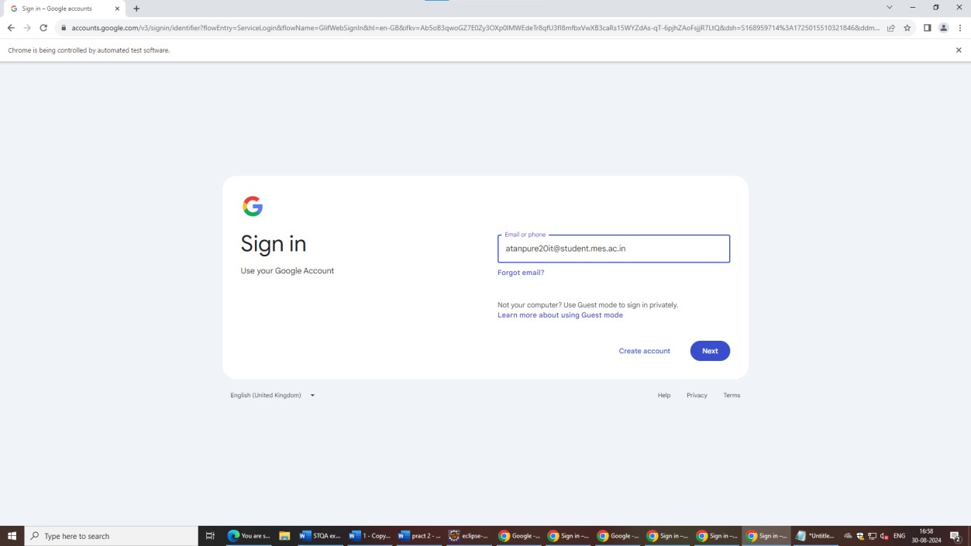

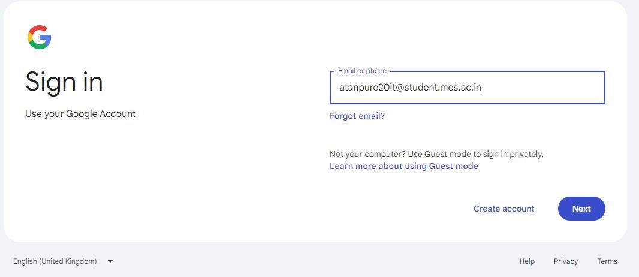

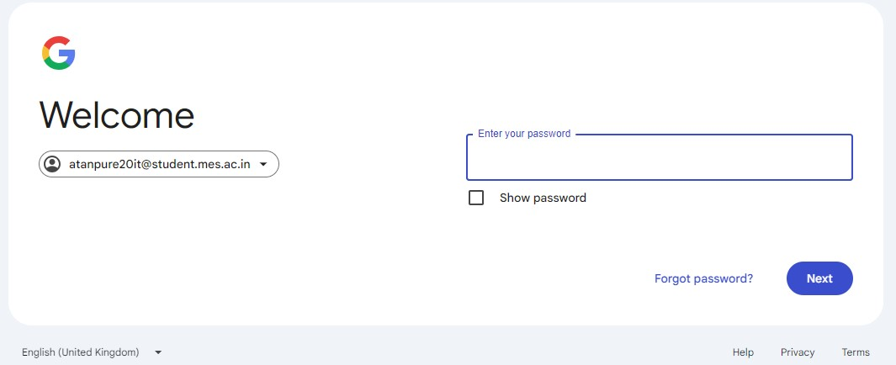

1. Go to facebook.com, click forgot password and give email (link and partial link)

CODE

|  |
| --- |
| package pract3;    import org.openqa.selenium.By; import org.openqa.selenium.WebDriver; import org.openqa.selenium.WebElement;  import org.openqa.selenium.chrome.ChromeDriver;    public class class1 {    public static void main(String[] args) {    WebDriver driver = null;  driver = new ChromeDriver();  //gmail  driver.get("https://adactinhotelapp.com/");  //xpatgh    driver.findElement(By.*xpath*("//*[@id=\"login_form\"]/table/tbody/tr[4] /td[2]/div/a")).click();    WebElement we= driver.findElement(By.*id*("emailadd_recovery")); we.sendKeys("supereme_tester@123");  }  } |

OUTPUT

